


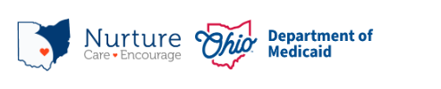
PRAF 2.0 NurtureOhio Interface:
County Department of Job and Family Services User Guide

Contents
Welcome New Users! 2
What is NurtureOhio? 2
NurtureOhio Features 3
Who Should Use NurtureOhio 3
What is a PRAF? 3
What is an ROP? 3
Benefits of Using NurtureOhio to Submit Pregnancy Notifications: 4
User Types 4
How to Obtain Access to NurtureOhio as a first time CDJFS User 5
How to Log into NurtureOhio 6
Forgotten Username or Password 7
NurtureOhio Initial Profile Setup 8
Updating User Information (the Edit User Profile Screen) 9
Welcome Screen 10
Processing Referrals 11
Accessing Referrals 11
Referral Reporting Screen 11
Adding Additional Concerns 16
Exporting 20
Exporting Referrals 20
Exporting PRAFs and ROPs 20
Log Out 21
Help Desk and User Support 21
Help Form 22
Maintenance and System Outages 22

Welcome New Users!
This guide will help you navigate the NurtureOhio website. Some of the key items provided are:

- Definitions of Perinatal Risk Assessment Form (PRAF) and Report of Pregnancy (ROP) related topics
- Step by step guidance on getting access to and logging into the NurtureOhio system
- Step by step guidance on member referrals process
- Features of NurtureOhio
- Help with troubleshooting
- Additional tips and resources

What is NurtureOhio?
NurtureOhio was developed in 2016, in partnership with the Ohio Perinatal Quality Collaborative, the Ohio Department of Health, 23 Medicaid Maternal and Fetal Medicine providers, and the five Medicaid Managed Care Organizations (MCOs) to standardize pregnancy notification and decrease the risk of preterm birth. Through continued spread, the project has since grown beyond the progesterone quality improvement project, and the NurtureOhio web-based system has become the Ohio Department of Medicaid’s preferred method for notification of pregnancy and the postpartum period for all Medicaid-insured individuals across the state.

NurtureOhio is a web-based system that stores and shares information about perinatal risks and health-related social needs (HRSNs). This information is collected using the electronic Perinatal Risk Assessment Form (PRAF 2.0) and the Report of Pregnancy (ROP). Once a user submits either the PRAF 2.0 or ROP in NurtureOhio, the data is seamlessly transmitted to Ohio Medicaid’s eligibility system to ensure maintenance of Medicaid coverage, the Ohio Department of Health (ODH) for connection to the Women and Infant Nutrition Program (WIC), the Ohio Department of Children and Youth (DCY) for evidence-based Home Visiting, County Department of Job and Family Services and the individual’s Managed Care Organization (MCO) for resources and identified needs.

NurtureOhio is used to notify the Ohio Department of Medicaid and key stakeholders of pregnancy and the start of the postpartum period for all Medicaid-insured individuals for eligibility maintenance and care coordination. Through the PRAF and ROP, NurtureOhio transmits the minimum information needed about Medicaid individuals’ pregnancy and postpartum information to the appropriate stakeholders to ensure their needs are met.

NurtureOhio Features
- Ability to export referrals, ROPs, and PRAFs
- Same day pregnancy notification
- Same day referral notification
- Ability to save and retrieve in process, completed and archived forms

Who Should Use NurtureOhio
- Clinical obstetrical providers should submit a Perinatal Risk Assessment Form (PRAF) on behalf of their patients.
- Clinical non-obstetrical providers, such as primary care providers, doulas, emergency department providers, local health department clinics, etc., when able to positively confirm the individual’s pregnancy, should submit a Report of Pregnancy (ROP).
- Community Based Organizations (CBO) and Managed Care Organizations (MCO) should also submit an ROP at the first notification/identification of a pregnancy.
- Managed Care Organizations (MCOs) and County Department of Jobs and Family Services (CDJFS) to assist with resource connection.

What is a PRAF?
The Perinatal Risk Assessment Form (PRAF) is an assessment that is intended for completion and submission by all obstetrical providers at the Medicaid patient's first prenatal visit, the start of the postpartum period, and whenever there are changes in the patient's perinatal medical, social risk factors or needs. The PRAF collects perinatal risk and health-related social needs. PRAF replaces the ODM 03535 form. The web-based version of the Perinatal Risk Assessment (PRAF 2.0) is ODM’s preferred method for submission.

What is an ROP?
The purpose of the Report of Pregnancy (ROP) form is to capture a Medicaid individual’s pregnancy as soon as possible to assist with eligibility and care coordination. ROPs are intended for submission at the first report of pregnancy. The ROP can be submitted by non-obstetrical Medicaid providers, Medicaid MCOs, and CBOs. For example, if a patient is on a telehealth visit with their primary care physician and reports being pregnant, an ROP should be submitted on behalf of the patient. An additional example would be if a patient is seen at the emergency department or a local health department and is determined to be pregnant, an ROP should be submitted on behalf of the patient. The goal is to connect the individual to obstetrical care and other services and ensure coverage throughout pregnancy and the postpartum period to optimize health care access and health outcomes for the mother and infant. Again, the ROP is only intended for submission by non-obstetrical Medicaid providers, Medicaid MCOs, Doulas, and CBOs.

Benefits of Using NurtureOhio to Submit Pregnancy Notifications:
- Updating pregnancy details in Ohio’s Medicaid Eligibility System to prevent loss of Medicaid coverage during pregnancy and postpartum period
- MCOs notification of potential members for care coordination and incentive programs to provide support and resources during pregnancy and the postpartum period
- Enables County Department of Job and Family Services (CDJFS) users to verify that pregnancies are added to the Ohio Benefits system and coordinate care via referrals
- Timely referrals to the Ohio Department of Health’s (ODH) Special Supplemental Nutrition Program for Women, Infants, and Children (WIC)
- Referrals to The Ohio Department of Children and Youth’s (DCY)Home Visiting Central Intake platform

User Types
Users are classified into six different user types which impact what views they have access to and how they enter information in the NurtureOhio system. For the purposes of NurtureOhio, ODM defines the following user types:
- Practice users as those users associated with a practice that provides obstetric services
- MCOs as those users affiliated with ODM’s contracted Managed Care Organizations
- Non-OBGYN are users associated with a clinical practice that does not provide obstetric services but can confirm an individual’s pregnancy via a positive pregnancy screening such as primary care, emergency department, urgent care, community health centers, community clinics, etc., and as those users identified by ODM as doulas.
- Secondary MCOs as those users affiliated with ODMs contracted Managed Care Organizations as secondary MCOs
- OEI Community Based Organizations and CBO Lead Entities as those users from organizations identified by the Ohio Department of Medicaid as Ohio Equity Institute Lead Infant Mortality Entities and their corresponding Community Based Organizations
- County Department of Job and Family Services Healthchek/PRS workers as those users specializing in pregnancy related services for CDJFS offices

How to Obtain Access to NurtureOhio as a first time CDJFS User
- CDJFS users will be given access in accordance with the current ODM directory for each counties PRS/Healthchek worker(s), any updates to contacts should continue to be sent to Healthchek_prs@medicaid.ohio.gov
- Once the new user is added, they will be notified via email
- When the new user logs into NurtureOhio for the first time, they will need to choose “Internal” from the dropdown box, enter their email as the username and then click “Forgot Password?” to set up their password for the first time
- The system will send a password reset to the user's email; the user should check the spam folder for the email if it is not in their main folder
- Users can reach out to momsandbabies@medicaid.ohio.gov for any user access issues and to add additional users for your county

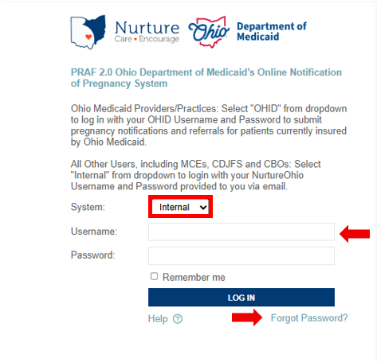

How to Log into NurtureOhio
To access the NurtureOhio website visit: https://www.nurtureohio.medicaid.ohio.gov
- Select "Internal" from the dropdown list, then enter your Username and Password. Click “LOG IN”
- Logging in allows users to retrieve and process referrals for members in their county
- Logging in allows users to receive notifications of pregnancy and verify that the pregnancy has been added into in the Ohio Benefits System, ensuring that coverage is maintained throughout the perinatal period

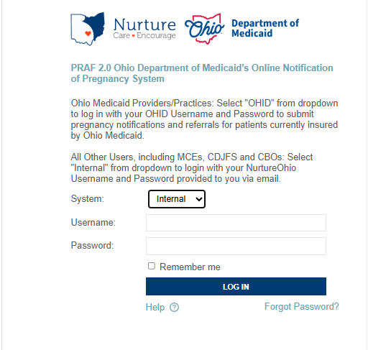

Forgotten Username or Password
If you need help logging in, contact nurtureohiosupport@deliverhealth.com.
If you have forgotten your username or password, select ‘Forgot Password?’ and enter the email associated with your user account.

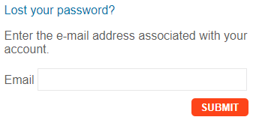

NurtureOhio Initial Profile Setup
After logging into NurtureOhio for the first time, users will be taken to “New User Profile Setup” page. Here users can update their password to something more memorable.
Once the user has updated their password, click “SAVE & BEGIN.” The user will be redirected to their welcome screen.

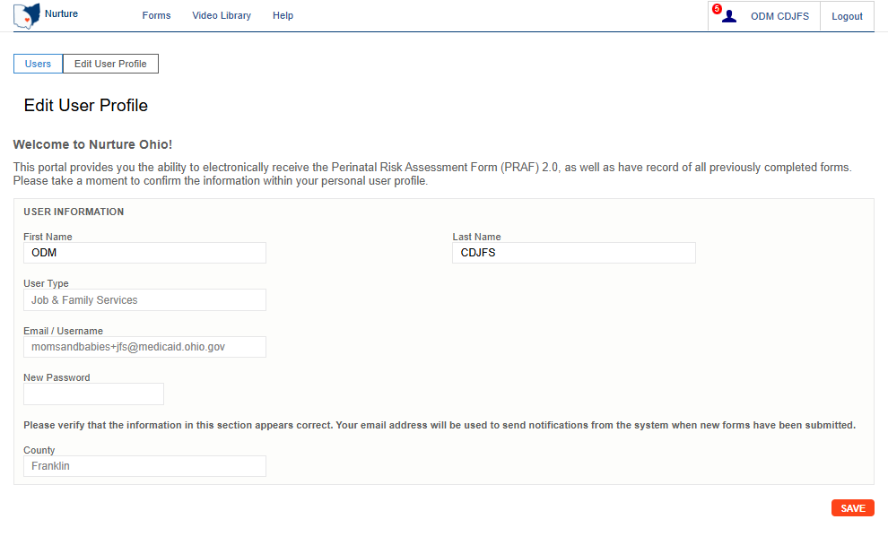

Updating User Information (the Edit User Profile Screen)
After clicking on the User ID on the Welcome Screen, users can edit information about their user account. On this screen, users can:
- Edit first name and last name
- Change their password
- View user type
- Verify that their username is correct
- Click the “Save” button to save any changes and return to the Welcome Screen. If no changes have been made, click the “Users” button at the top left of the screen
Note: Some information associated with your User ID will be inserted automatically. You will not be able to edit this information. Contact ODM at MomsandBabies@medicaid.ohio.gov to submit edits if needed for prepopulated information.
Be sure to click the “Save” button at the bottom on this screen to save any changes you make.

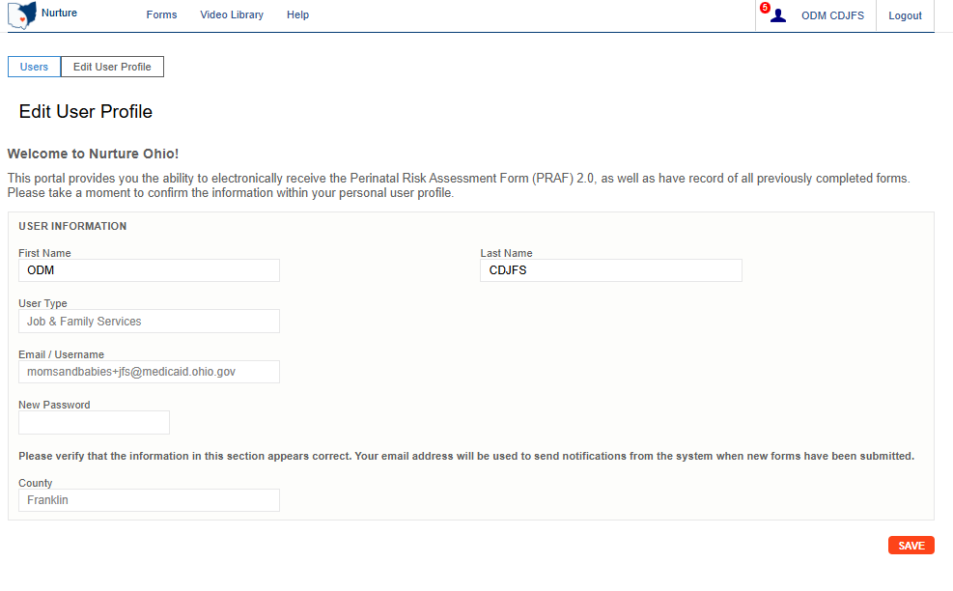

Welcome Screen
After logging in, CDJFS users will be taken to the Welcome Screen. The Welcome screen allows users to perform or access multiple tasks, including:
- Updating user information by clicking on the User ID
- View submitted PRAFs and ROPs for their County
- View referrals for their County
- Searching for existing forms using any of the following:
- Patient Name
- Patient DOB
- Patient Medicaid transmission status
- Date of Creation (Specific date or date range)
- Date of Service (Specific date or date range)
- View organization notifications
- Exporting multiple ROPs or PRAFs to a CSV file

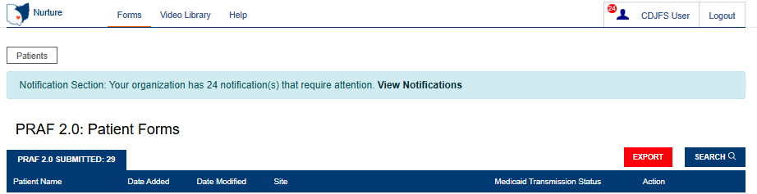

Processing Referrals
When filling out a PRAF or ROP, submitters can request the patient’s CDJFS office to follow up with the patient regarding a variety of needs. When needs are selected on the PRAF or ROP, a referral is created in NurtureOhio. CDJFS users can then log into NurtureOhio to process these referrals and report on the outcome of the referral. CDJFS will determine internally who is responsible for processing referrals for their county. Currently, this will be the Healthchek/PRS worker’s responsibility.

Accessing Referrals
If a CDJFS user has any referrals that require attention, a ‘View Notification’ message will appear at the top of the screen. CDJFS users will receive a notification for new PRAF 2.0 forms, new ROP forms, and incomplete referrals.
A small red circle will also appear next to the User ID indicating how many notifications a user has.
Click ‘View Notifications’ to open a drop-down menu under the User ID. Click ‘Referrals’ on this menu to go to the Referral Tracking screen. Users can also select ‘Referrals’ from the Forms menu at the top of the screen.
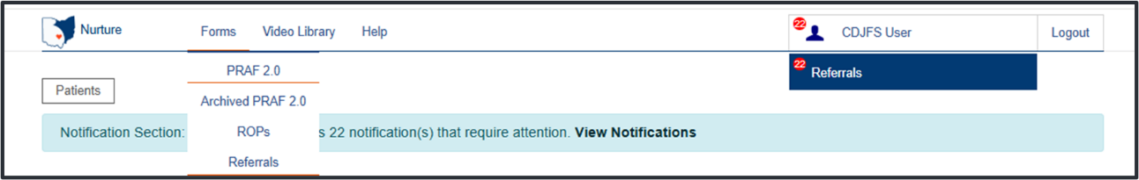

Referral Reporting Screen
The Referral Reporting screen shows referrals that have been indicated on both submitted PRAF and ROP forms. The ‘Needs’ column helps to easily identify what the patient needs assistance with. The Member Name is a hyperlink, click to proceed and work the referral.
There are four tabs: Referral Requests, In Progress Referrals, Completed Referrals, and Archived Referrals.
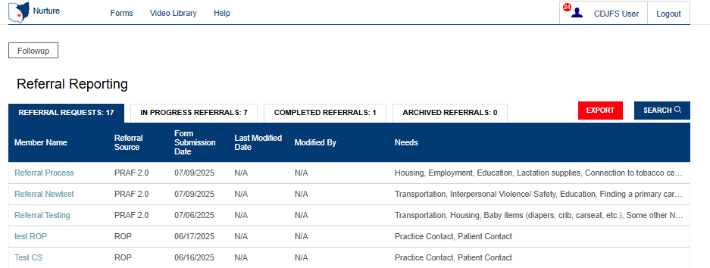

All forms will stay in the ‘Referral Requests’ tab until at least one field is completed on the referral. To start processing a referral request, click on a member’s name and the ‘Referral Follow-Up Answers” screen will open. On this screen users can:
- Easily view the Patient Information to assist with patient contact.
- Click the ‘View Complete PRAF 2.0’ or ‘View Complete ROP’ button to view the patient’s submitted PRAF or ROP
- View needs that have been indicated on the PRAF or ROP for referral
- Provide information regarding the outcome of the referral
- Add additional needs for referral that have not already been identified

Below is the Patient Information displayed on a referral created from a PRAF submission. Fields displayed include: Name; Date of Birth; Medicaid ID; Phone; Email; Language; County; WIC Referral (Y/N); Home Visiting Referral (Y/N).
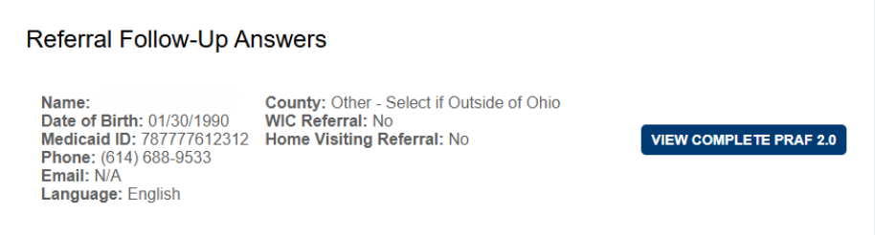

Below is the Patient Information displayed on a referral created from an ROP submission. Fields displayed include: Name; Date of Birth; Medicaid ID; Phone; Email; Language; County; WIC Referral (Y/N); Home Visiting Referral (Y/N); Prenatal Visit Scheduled (Date); Assistance Scheduling Appointments (Y/N).
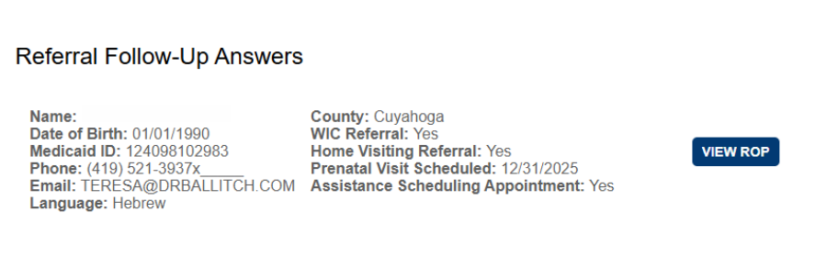

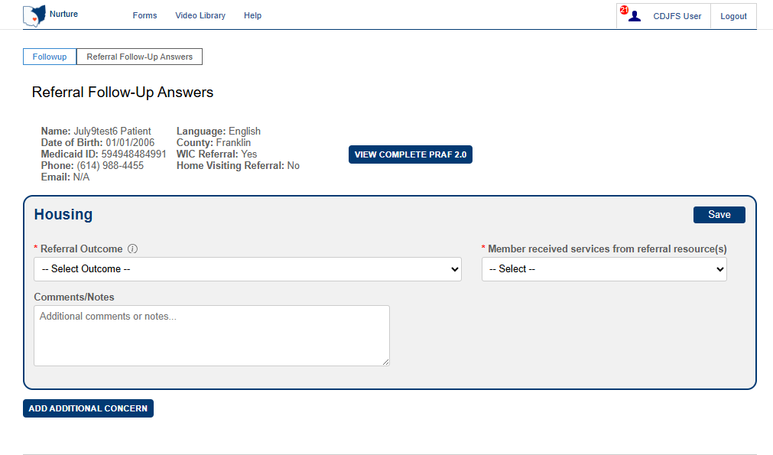
Tooltips provide additional information, hover over the tooltip to open it.

To process a referral, select an answer from each drop-down menu for each need. Complete all required fields and when finished, click “Save”.

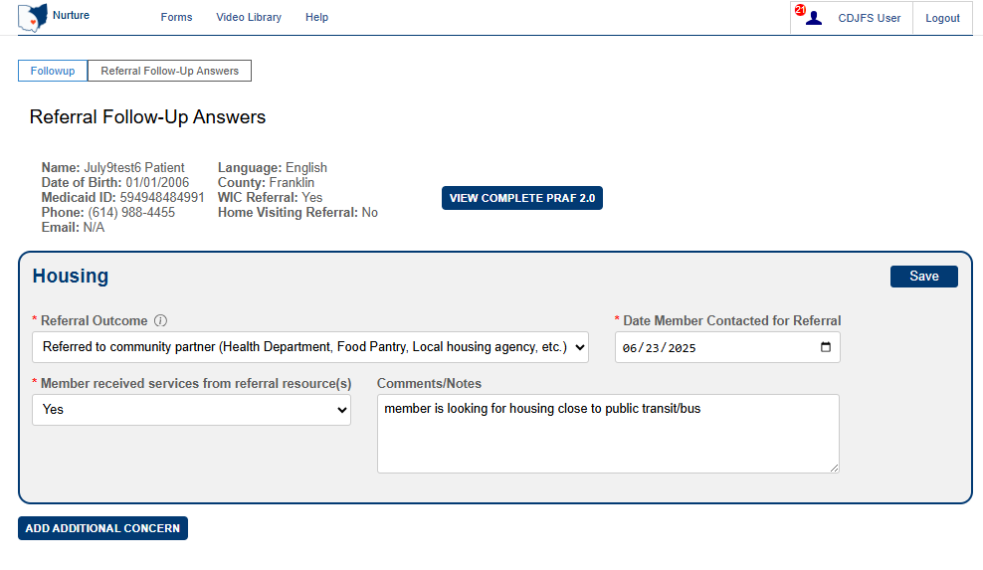

After referrals are saved, you will see a “Last Saved” date and time. This will help users to keep track of the action taken on referrals.
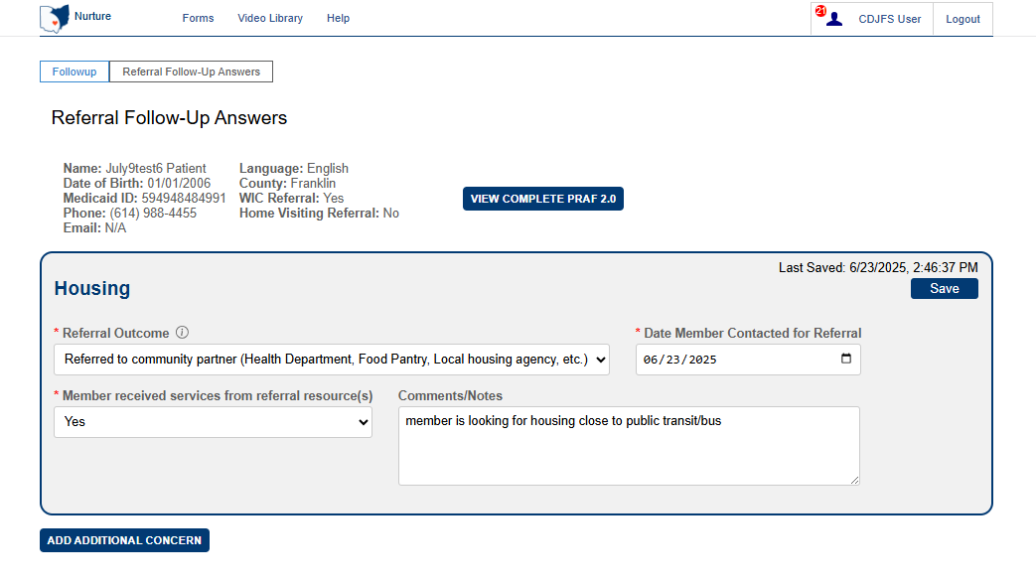

Note: Users can enter information in the ‘Comments/Notes’ field to provide additional information about the member or take progress notes. Entering information in the ‘Comments/Notes’ field does not change the status (Example: Referral Requests/In Progress Referrals/Completed) of the referral. Click ‘Save’ after entering information in the ‘Comments/Notes’ field to save your data.

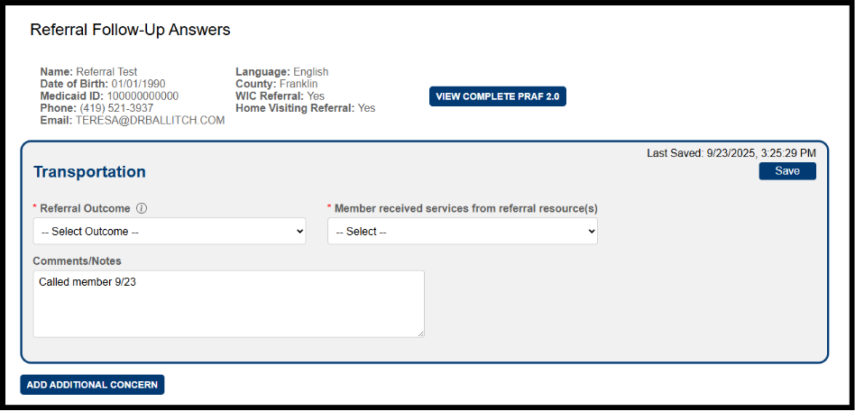

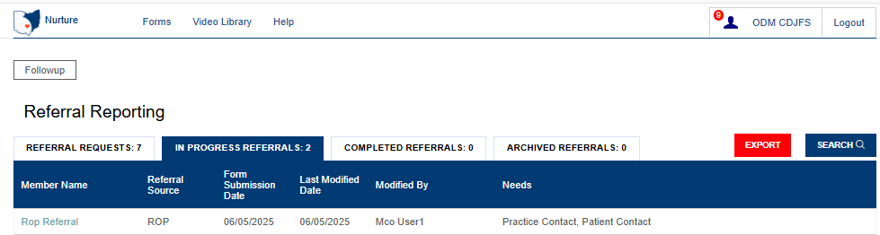
If any concerns still require completion, the referral will move to the “In Progress Referrals” tab. Referrals can be edited under this tab.

If all concerns are addressed and saved the referral will move to the “Completed Referrals” tab. Referrals can be edited under this tab.
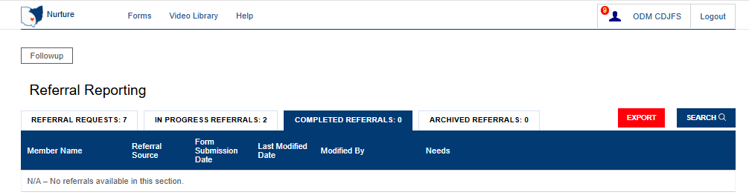

All completed referrals will move to “Archived Referrals” after 365 days of completion.
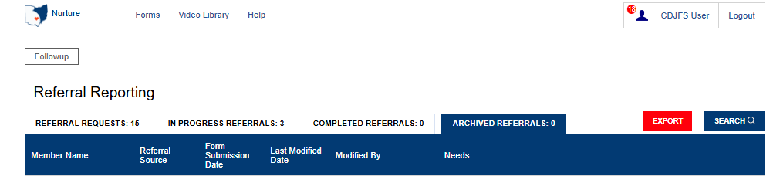

Adding Additional Concerns
Users can add additional needs not identified on the PRAF or ROP for referral. For instance, an additional concern may be added for a patient who has already had a PRAF or ROP submitted but later found to have a previously unidentified risk factor or referral service/need.
For PRAF referrals, additional concerns that can be added are:
- Transportation
- Food
- Housing
- Utilities
- Interpersonal violence/Safety
- Employment
- Education
- Finding a behavioral health provider
- Finding a primary care provider
- Finding a pediatrician
- Baby items (diapers, crib, carseat, etc.)
- Connection to lactation consulting
- Lactation supplies
- Connection to tobacco cessation services
- Connection to substance use disorder services
- Connection to alcohol-related services
- Connection to opioid use services
For ROP referrals, additional concerns that can be added are:
- Transportation
- Food
- Housing
- Utilities
- Finding an OB/GYN provider
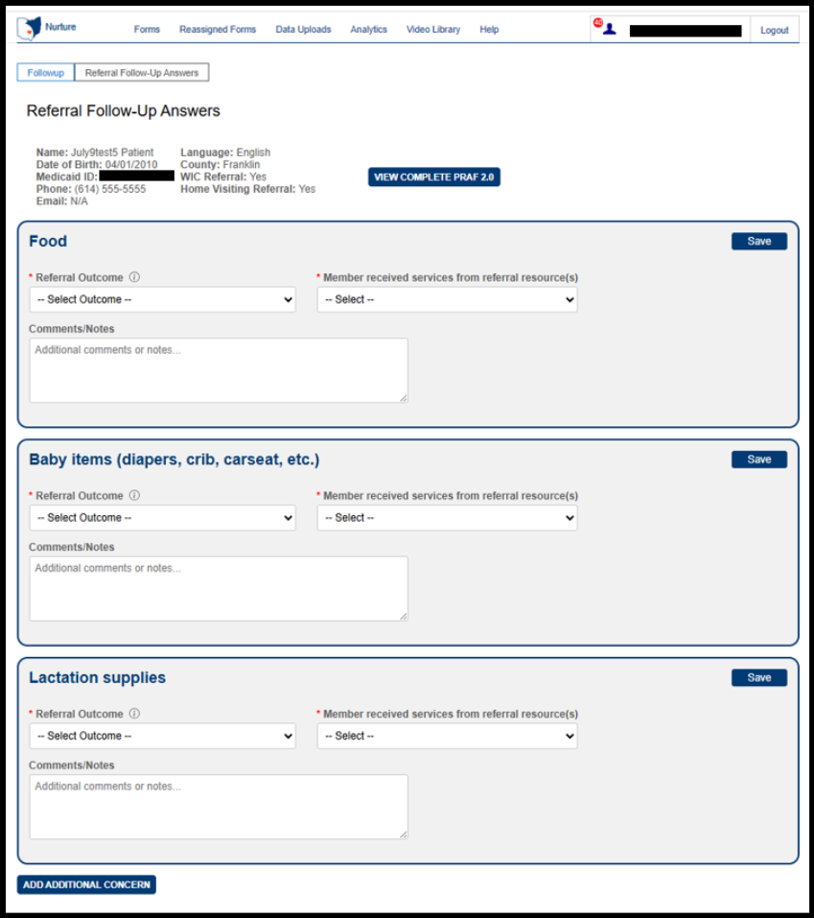

The ‘New Referral Follow-Up’ screen will open, allowing you to add a referral.
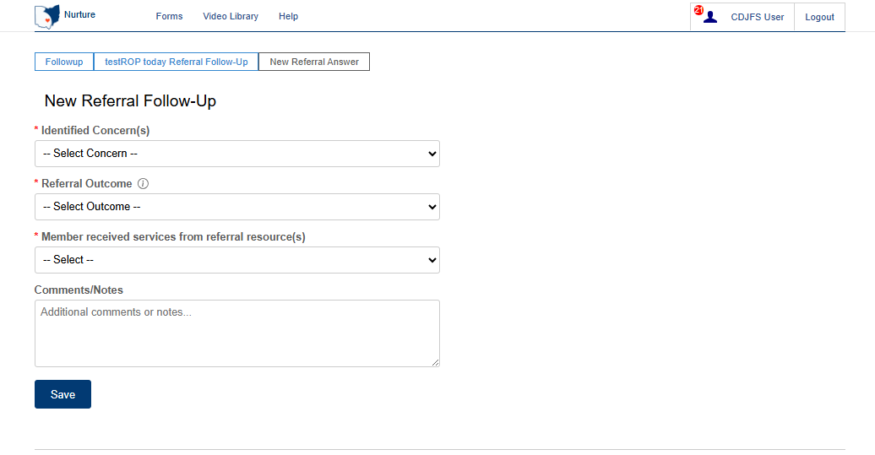
Select the additional concern from the dropdown to create a new needs referral item (PRAF and ROP options displayed below).
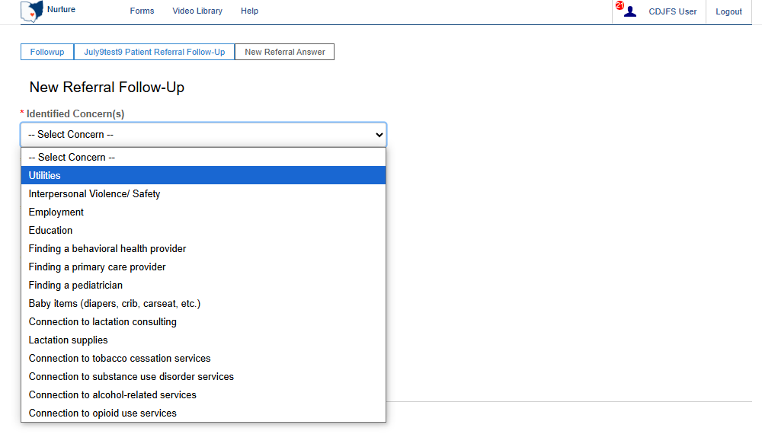
Select identified need from the dropdown. Only items not already indicated on the referral will be listed as options. Once complete this will show as a referral.

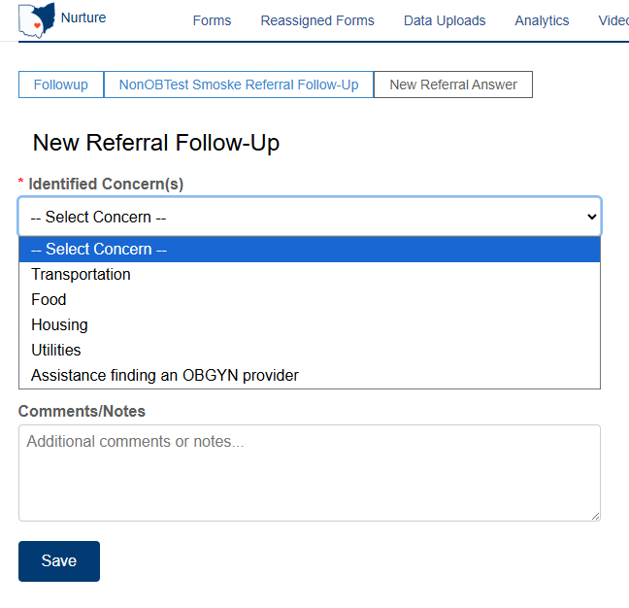

Once the additional concern entry is saved, it will appear on the “Referral Follow-Up Answers“ screen.
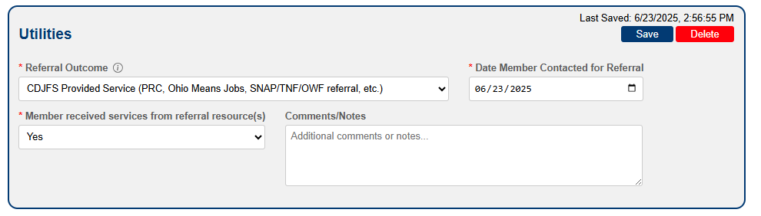

Note: Users will only have the option to delete manually added additional concerns. All concerns submitted via the PRAF and ROP will need to be completed.

Exporting

Exporting Referrals
The Export option allows you to export all referrals associated with the logged-in CDJFS user.
Click the Export button at the top of the Referral Reporting screen next to the Search button. The dropdown menu will provide you with export options for referrals. Once you select an option, the file will be exported and saved to the default download folder on your local machine.

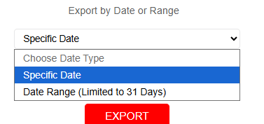
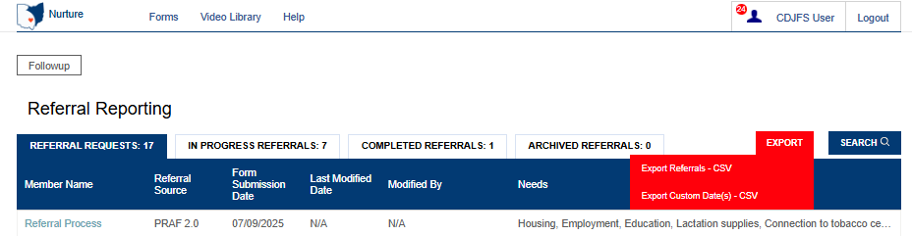

Exporting PRAFs and ROPs
Users also have access to export PRAFs and ROPs associated with the logged-in CDJFS user. Click the Export button at the top of the PRAF or ROP screen next to the Search button.

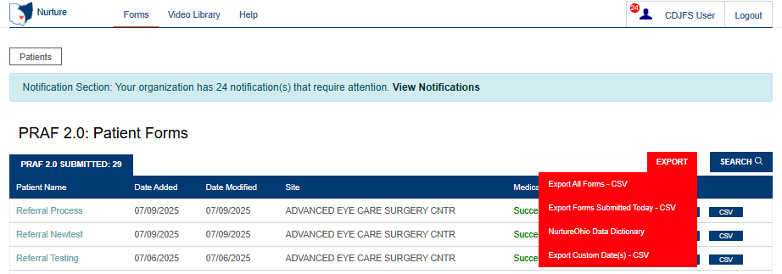

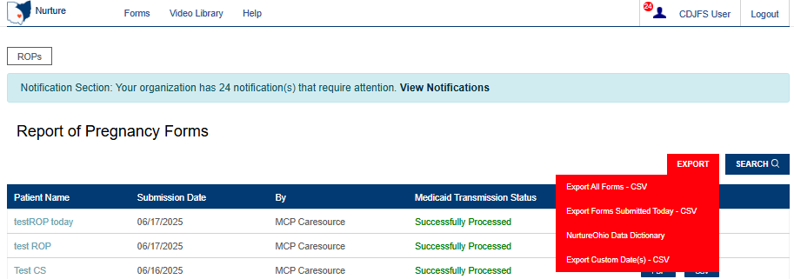
The dropdown menu will provide you with export options for PRAFs and ROPs. There is also an option for exporting the NurtureOhio Data Dictionary. This document describes the details of the file output. Once you select an option, the file will be exported and saved to the default download folder on your local machine.

Log Out
It is important to log out of the NurtureOhio system when finished.
- Select “Logout” in the top right-hand corner of the screen.

Help Desk and User Support
If you have any concerns or issues with the website or are unable to view fields, please use the “Help” button shown in the screenshot below.
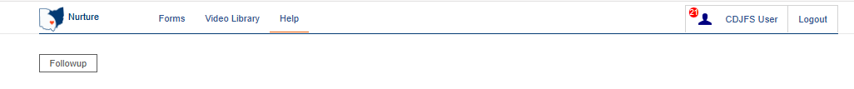

Help Form
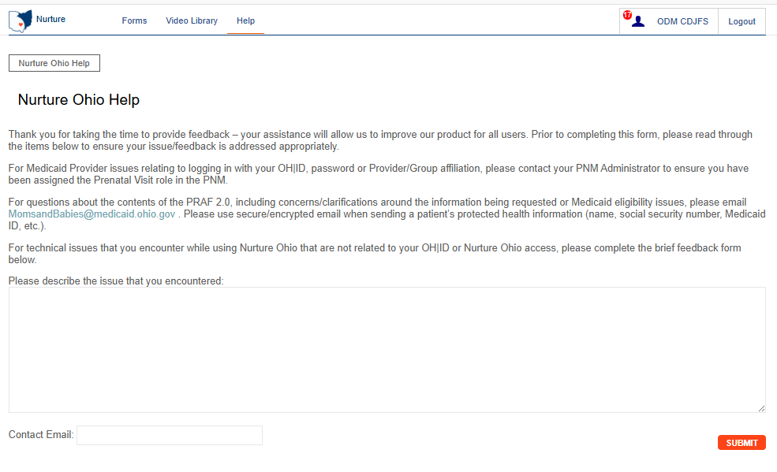

You will then want to describe the issue that you are experiencing in the text box. Include a contact email and then click ‘Submit.’
If you have any general questions regarding the referral process, please email MomsandBabies@medicaid.ohio.gov with the Subject “CDJFS referral help”.

Maintenance and System Outages
If the NurtureOhio system is shut down for maintenance, you will receive an e-mail from the Nurture Helpdesk (no-reply@duethealth.com).

